BOLD Cities first ‘data dialogue’ successful
On Thursday February 8, the BOLD Cities team held its first ‘data dialogue’ in collaboration with the client council of the city of Rotterdam. The data dialogues are an integral part of the team’s big data research into the possibility to personalize job seeking strategies for people on benefits. The research exists for one part of extensive data linking and analysis: all relevant micro data of the Dutch Office of National Statistics (CBS) are combined with personal unemployment data of the city of Rotterdam to find out if and how particular job seeking instruments work for particular persons. The aim is to develop better and more personalized support for people who are dependent on unemployment and social benefits. In line with BOLD cities’ aim to empower people vis-à-vis the institutions using their data, the research also contains a significant endeavour to work with the ‘clients’ of municipal benefit systems, informing them of the aims, data-usage and forms of analysis in the project, and inviting them to share their hopes and concerns about the outcomes of the project.
In the morning of our session, we introduced our ‘data base game’, which we designed to explain how the linking of data coming from different data bases works, what pseudonymization is and how one can detect profiles in data sets. The participants appreciated this form and thought it was a good, hands-on manner to better understand this type of data analysis.
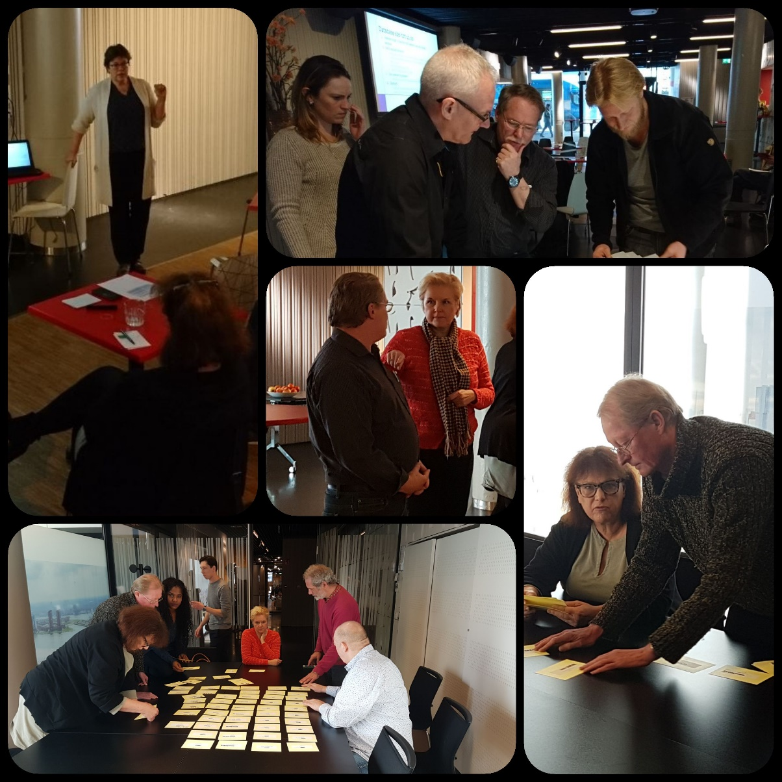

In the afternoon, we asked our participants to fill in a questionnaire with a number of privacy statements (including questions about transparency and data ownership), after which we discussed these questions in more depth in small, focus group settings. Concerns that emerged across the groups:
- Our participants do not know who has access to their personal data and fear that a range of arbitrary city employees are able to enter their personal file;
- Our participants also feel that they have to share all kinds of information that is irrelevant to their right to an allowance and their efforts to find work;
- Our participants are frustrated that they have to tell their own personal story again whenever they are confronted with a different case manager;
- There was a general feeling that the quality of some case managers was below desirable operational standards;
- Many stories were shared about problematic interactions with case managers, and many of our participants have at times felt humiliated and denigrated by the benefit system and its executors.
We observed a paradox between the fear of our participants that different arbitrary people have access to their personal file, and the frustration about having to tell your own, often painful, story over and again to new case managers. A personal data vault solution was discussed: this is a situation in which people have their own digital data vault, which they manage themselves and from which they only share the data that is requested and needed in particular situations. This option met with enthusiasm from some people who thought such personal data ownership and control was a matter of principle. Others thought the focus should be on improving the operational qualities of the Rotterdam benefit organisations. They felt that they and other more vulnerable people would miss the systematic, efficient mind-set that is needed to maintain such a vault (our team acknowledged that we ourselves wouldn’t be very good at it).
We concluded the day with a short discussion of the EU General Data Protection Regulation and the Dutch law through which it will be implemented from May 2018. We discussed that this AVG may have repercussions for article 17 of the Dutch Participation Law which regulates the duty of people on benefits to share information with benefits organisations.

